Subnetting (Solved Problem 6)

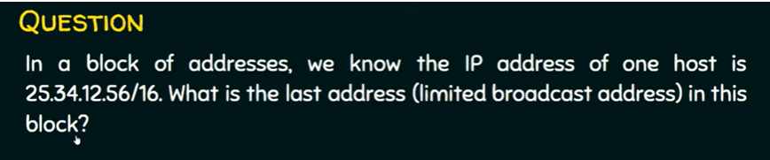

Solution 1

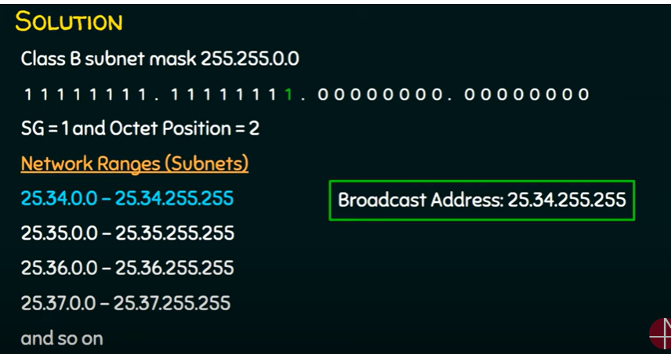

Solution 2

We need to get the complement of the mask when doing the or operation

